**NLA ID Web Application -- User Guides**

1. **Go to Login Page**: <http://dc7-dev2.anu.edu.au/index_login_nla.php>

username: (contact administrator)

Password: (contact administrator)

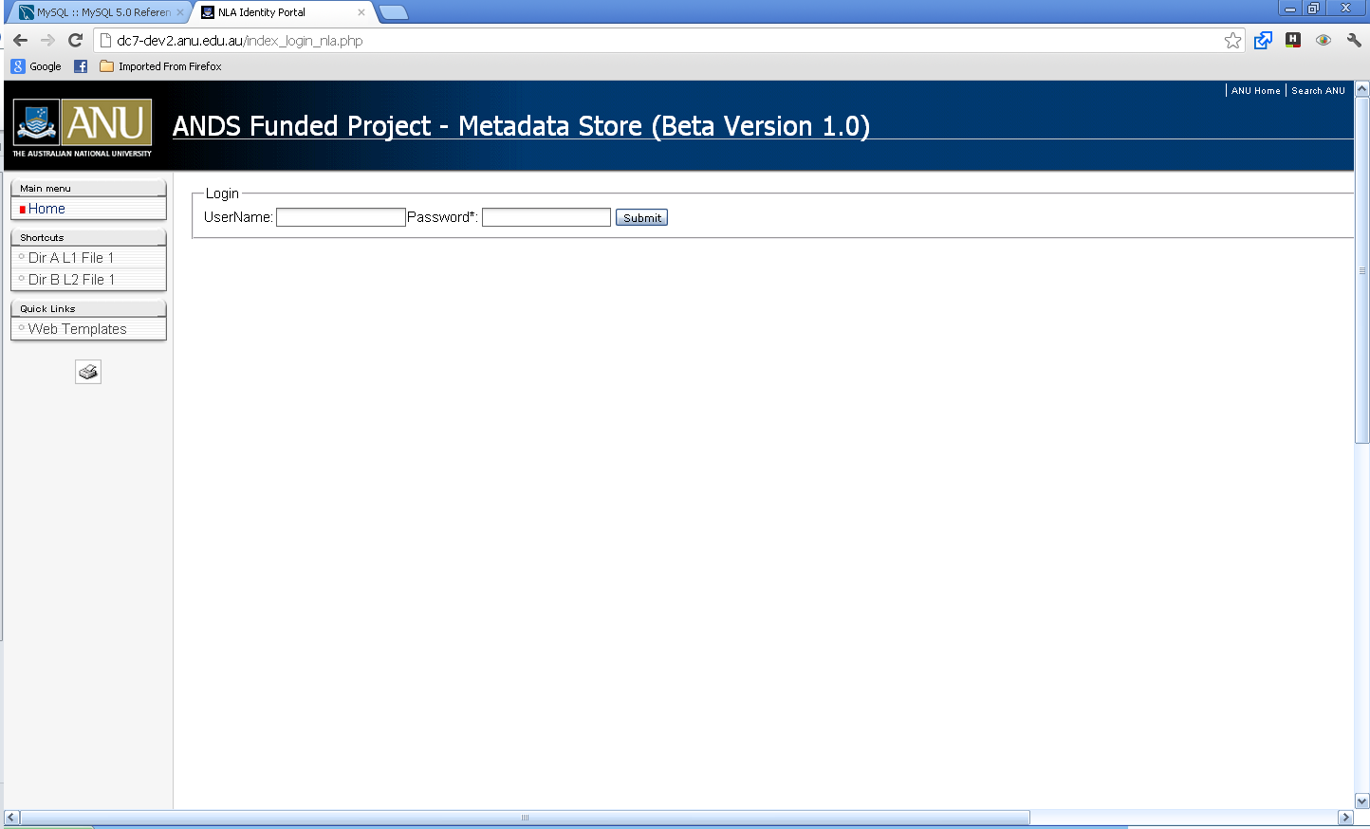

1. **The main Page** shows the list of ANU people with Description information.

Some of them in the list already have NLA IDs.

The Deidentified Staff ID is being used to maintain confidentiality of the Staff private information (e.g: university ID). It is a concatenation of Letter “I” and ARIES’s Staff System ID. For example: I1234.

1. Search the ANU general information using the “Deidentified ID”.
2. The mapping of University IDs and the Deidentified ID is provided in a separate file.

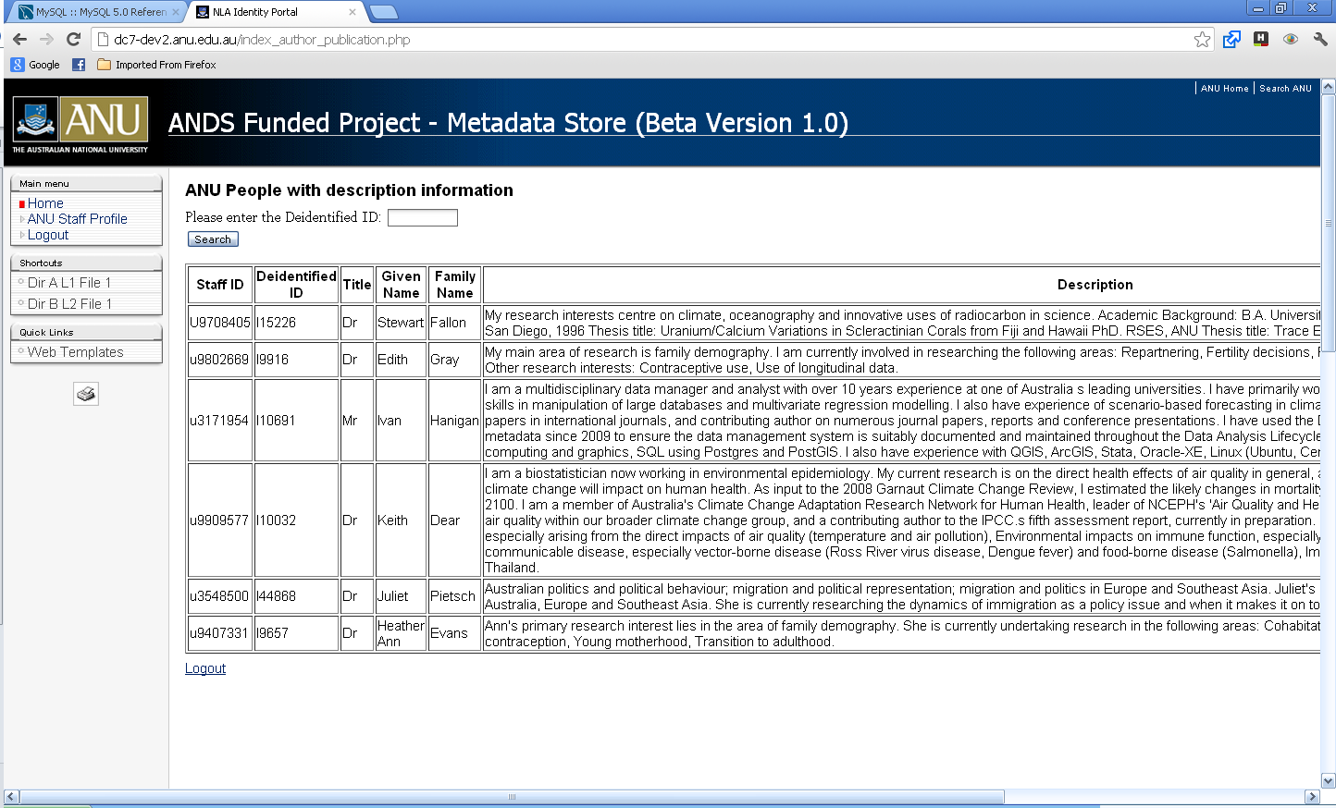

1. **The General information of ANU Staff Profile page.**

The data displayed on this web page has been extracted from the ARIES database (snapshot as of 5th December 2012).

The user may update/edit the data about the person, then click “**confirm**” button to update the information in the database. For the *Description*, the user may update the content in the “Description Updated” field.

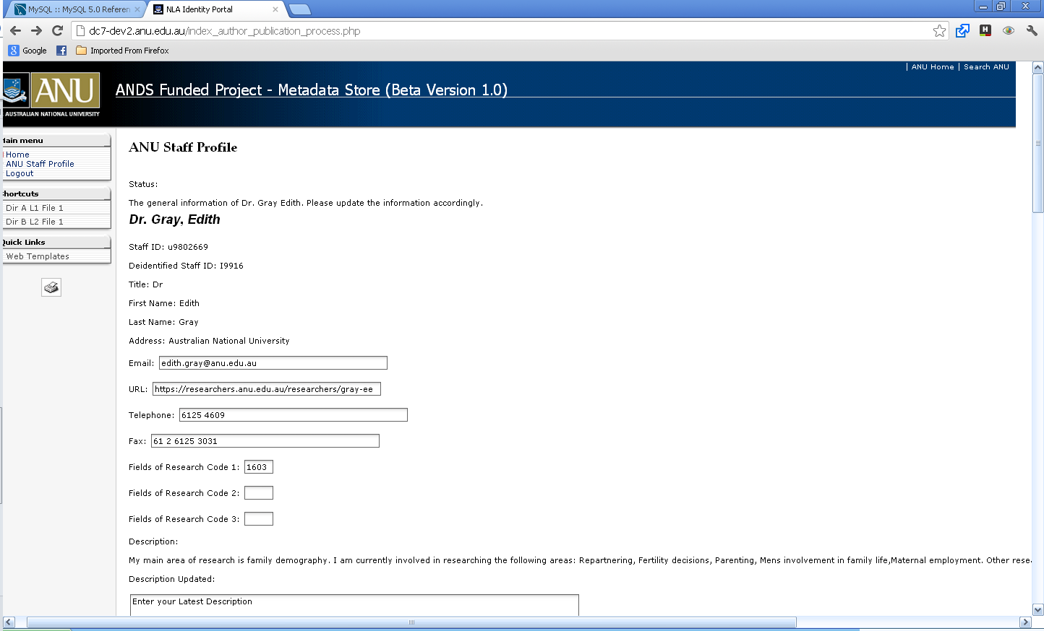

1. **The Staff Profile Updated Page.**

This page displays the result of the “updated” information from the previous page. To finalize the profile and store it in the XML page to feed to the NLA.

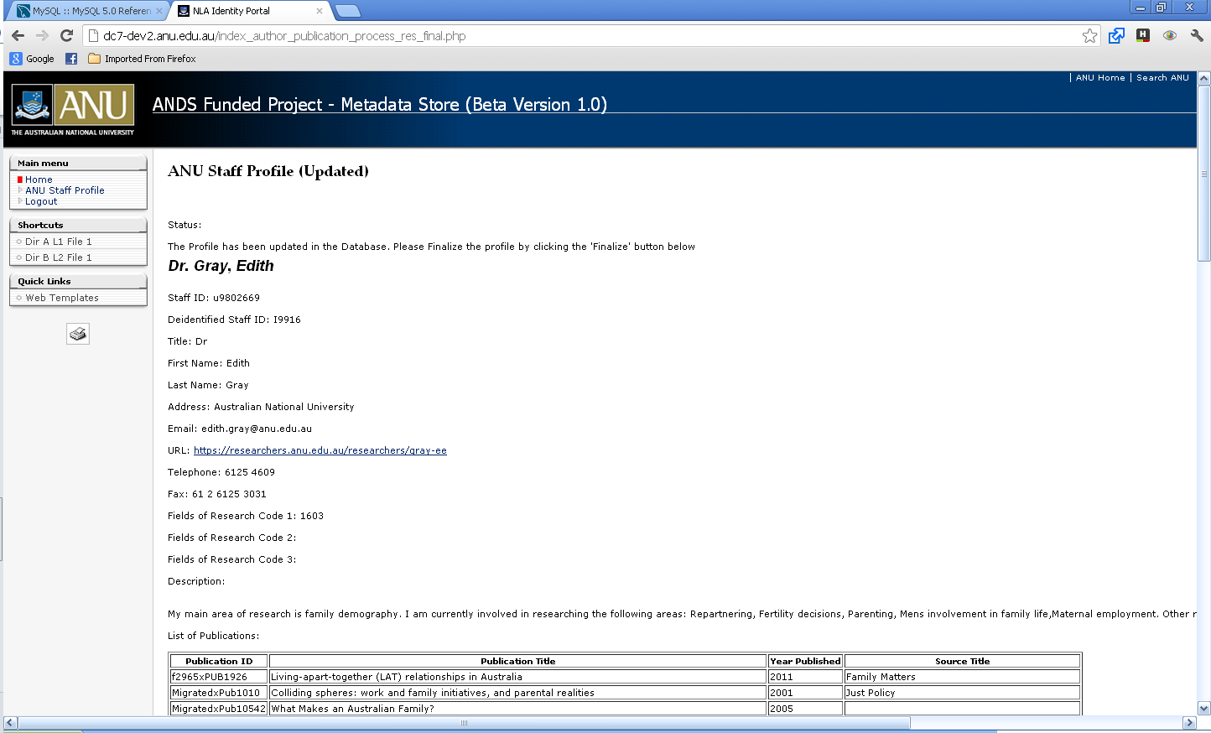

1. **The “finalized” Staff Profile Page.**

This is the final page that displays the information to fed to the NLA. To see the actual OAI-PMH result please click the “ [Please click on this link to see the OAI-PMH result](http://dc7-dev2.anu.edu.au/oai/oai2.php?verb=ListRecords&metadataPrefix=rif)” link.

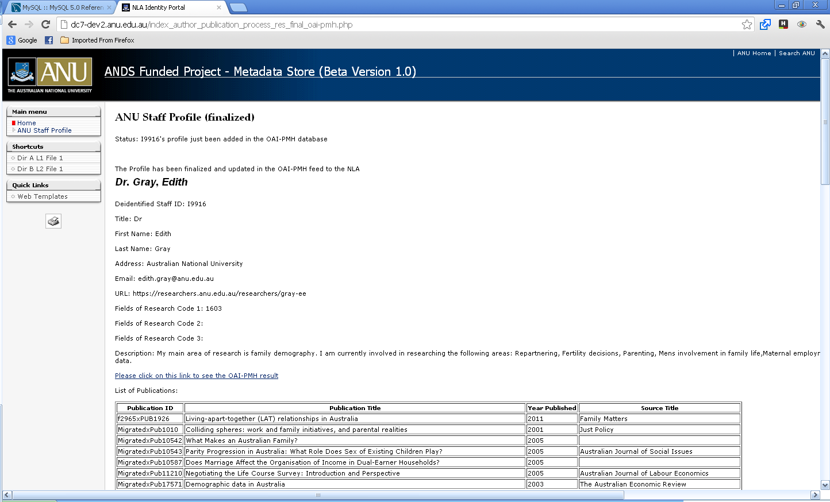

1. **The OAI-PMH result page**: display the XML formatted data to be fed to the NLA.

Link : <http://dc7-dev2.anu.edu.au/oai/oai2.php?verb=ListRecords&metadataPrefix=rif>

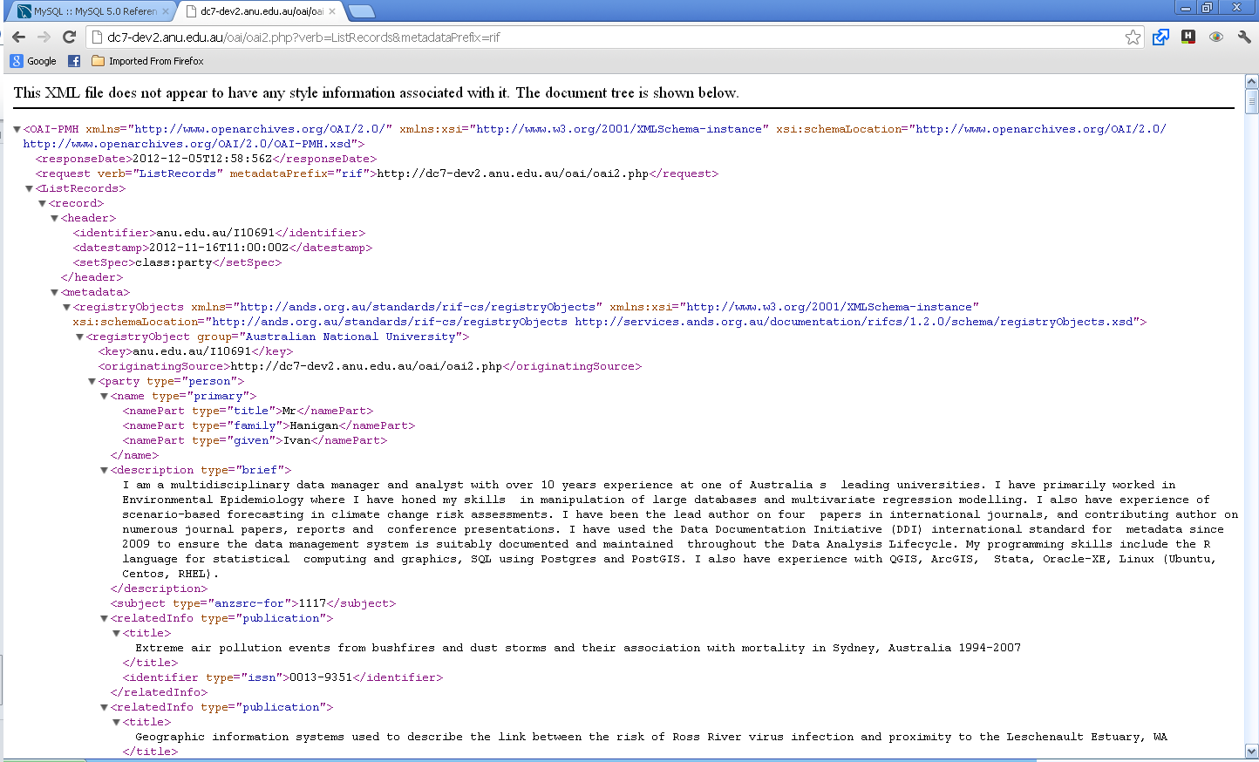

Other useful website: Trove Identies Manager. To resolve the unmatched people records.

[https://www.nla.gov.au/tim/app/#](https://www.nla.gov.au/tim/app/)